http://www.travelmozo.com

Introduction
We are setting up a new Travel portal which will be developed using Drupal 7.

This portal will be a complete travel portal with travel guides, articles, hotel reviews, forums and much more.
It is dynamic portal and we will keep adding new features as it grows. There is no end date of this project.

Examples of similar sites
http://www.virtualtourist.com/
http://www.tripadvisor.com/
http://www.lonelyplanet.com/
http://www.travelpod.co.uk/ - Nice Design
http://strayoutdoors.com/
http://www.afropolitan.co.za/travel/246-afro-travel-kenya-the-jewel-of-east-africa
http://www.raveable.com/il/metropolis/summers-riverview-mansion-bed-and-breakfast/i305678
http://www.roughguides.com
http://www.worldtravelguide.net/

Work
We don’t want providers to upload content, we want only a structure in place, we will upload content by ourselves.

http://www.lonelyplanet.com/ is the best website for example; we want to show most of the features from this site

Work style
We need to work together. Provider should be online on skype and whenever any feature is implemented he should let me know so that I can test on fly and provide any feedback immediately.
TravelMozo Main features
- Content
- Forums
- Shop
- Advertisement
- phpList
- Affiliate Integration – Expedia/others

TravelMozo Content Types
- Destinations
- Attractions
- Articles
- Things To Do
- Forum
- Shop
- Basic Page

Work to be done

Error
http://www.travelmozo.com/forums/cheap-hotel-bangkok
Notice: Undefined index: hs_lineages in hs_taxonomy_field_formatter_view() (line 402 of /home/travelmo/public_html/sites/all/modules/hierarchical_select/modules/hs_taxonomy.module).

http://www.travelmozo.com/thailand
See this block

Travel Guides
Configure
Thailand
Chiang Mai Province
Bangkok
Phuket Province
Mae Hong Son Province

And whenever we add any new term in vocabulary or new content this should take correct link. This problem happens when there is a space between names.
http://www.travelmozo.com/

Links are incorrect, http://www.travelmozo.com/Chiang%20Mai%20Province should be http://www.travelmozo.com/chiang-mai-province

Slideshow
  - Hide the node when there is no slideshow image attached to that node

Taxonomy Terms
http://www.travelmozo.com/admin/structure/taxonomy/destinations
When you add a term and select the parent terms and click on add it adds the term 2 times.
http://www.travelmozo.com/admin/structure/taxonomy/destinations/add
Enter Mathura in name
in Relations
select
Asi
-> India
Uttar Pradesh
and add it

Gmap
- On http://www.travelmozo.com/node/add/destinations
The gmap doesn’t automatically finds the location. Is it possible to fix it so that when we enter the city/state/country it finds the map?
- Show the gmap inside the node on the right side of location
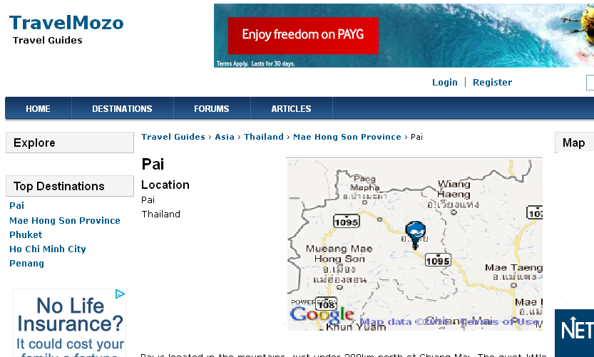

- Instead of Drupal marker us yellow colour marker
- Make gmap to be a link to open in popup window (pref.) or in a new window

Forum
- Forum Blocks
    - On the destination/attractions/etc… nodes show the forums topics from the respective place’s forum
E.g.
On http://www.travelmozo.com/bangkok/attractions/little-arabia-bangkok show the topics from Bangkok forum only - http://www.travelmozo.com/forums/asia/thailand/bangkok

    - When there is no post in the forum then don’t show the block

Photo Gallery
- We need a photo album and photo gallery module to be installed/configured/customized. This module will allow users to upload photos, allow photos to be organized into galleries.
    - User shall be able to upload photos. But make them to create a Gallery first, each photo should be in a gallery.
    - Show Image Alt tag, Tags and description field to each photo.
    - For gallery the fields needed would be tags, description
    - Allow them to make a photo to be the gallery main image
- Gallery display
    - On a gallery page show all the galleries in grid.
    - On a photo page show the photo on the top and the rest of photos in the gallery at the bottom
    - Each gallery/photo should have it’s own url
E,g,
travelmozo.com/london-photo-gallery
travelmozo.com/london-photo-gallery/big-ben
    - On each photo page show the rating, thumbs up thumbs down, overall rating – only registered/logged in users hall be able to rate.

Review module
- We need a way to allow user to review various type of contents. This module should allow user to review and rate various type of content such as Destination, Attractions, Hotels etc.
- We need this module to be flexible to allow having various criteria for the reviews. E.g. for hotels we want following criteria
    - Services
    - Price
- We should be able to add new parameters from the admin
See some examples of such reviews
http://www.lonelyplanet.com/spain/barcelona/restaurants
    - http://www.lonelyplanet.com/spain/barcelona/restaurants/cafe-3/cafe-zurich

Hotel Reviews
Hotel Review Format
http://www.tripadvisor.co.uk/UserReviewEdit-g187323-d589462-a_placetype.10023-ehttp:__2F____2F__www__2E__tripadvisor__2E__co__2E__uk__2F__Hotel__5F__Review__2D__g187323__2D__d589462__2D__Reviews__2D__Melia__5F__Berlin__2D__Berlin__2E__html-Melia_Berlin-Berlin.html

Review title
Review
Purpose
() Tourism () Business
Date of travel:

Rating
Rooms
Service
Staff
Facilities
Cleanliness
Location
Swimming Pool
Activities
Value for money

Overall Rating

Upload Photos – Photo title, tags, description
[ ]

[ ] Agreement check box
Submit

User
- User Registration
    - Places visited
      - Show one box to add places visited
      - Allow to add move boxes + to enter more places visited
      - Allow places to show up in these boxes when users type the place. May be using Location module or something?
- Fields
    - Add user profile photo
    - Show profile photo in user’s page
- Top Users (by points)
    - Show a block in 5x4 grid with user profile pictures.
    - Show top users by points (using points module)

Articles
- http://www.travelmozo.com/articles
    - Show the review, rating, thumbs up on the right side

Shop
- This will be linked to Amazon. Have to work out how to do it best.
- We will add all items from amazon manually and also link so it should be easy. When user clicks on the buy now it will go to the Amazon shop.
- Few modules
http://drupal.org/project/amazon
Guide - http://drupal.org/node/595464

Or
http://drupal.org/project/amazon_store - This module doesn’t work
- Shop categories
Shop will be categoriezed as below
  - Books
    - Travel Guides
      - Book name

We need to add Shop Menu in the main navigation menu
The shop page will list top items from all categories such as Books etc.

Breadcrumb

Points system
- 10 points for adding new article
- 5 points for reviews for any content type
- 3 points for any forum post
- 2 points for comments
- 5 points when all the fields in user profile are filled

Site Performance
Improve site performance for faster page loading.

